**RIPHAH INTERNATIONAL UNIVERSITY, ISLAMABAD**



**Lab # 9**

**Bachelors of Computer Science – 6th Semester**

**Subject: Operating System**

**Submitted to: Ms. Kausar**

**Submitted by: Javeria Inam_39977**

**Date of Submission: 20- Oct -2024**

**Exercise 1:**

Run following script. And examine output.  **01**

**Answer**

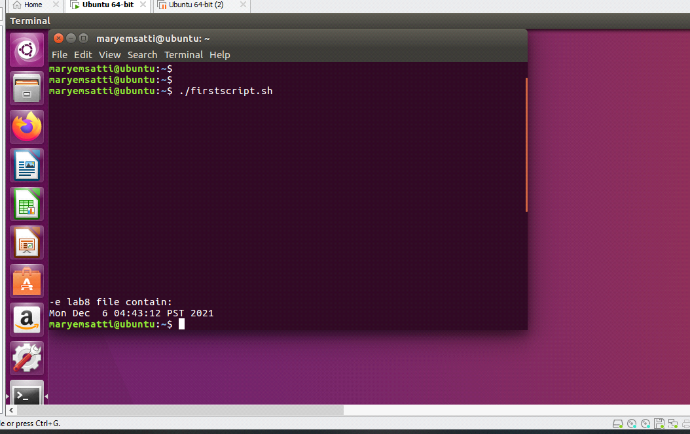

**Exercise 2:**

A file contains following script. Execute this code. **01**

#/bin/sh

x=5

y=0

echo "The value of X = " $x

y=$(expr $x + 5)

echo "The value of Y = " $y

**Answer**

The **output** of the above program is

**The value of X = 5**

**The value of Y = 10**

**Exercise 3:**

Write shell script that reads 2 integer values from user and print their sum on screen. **02**

**Answer**

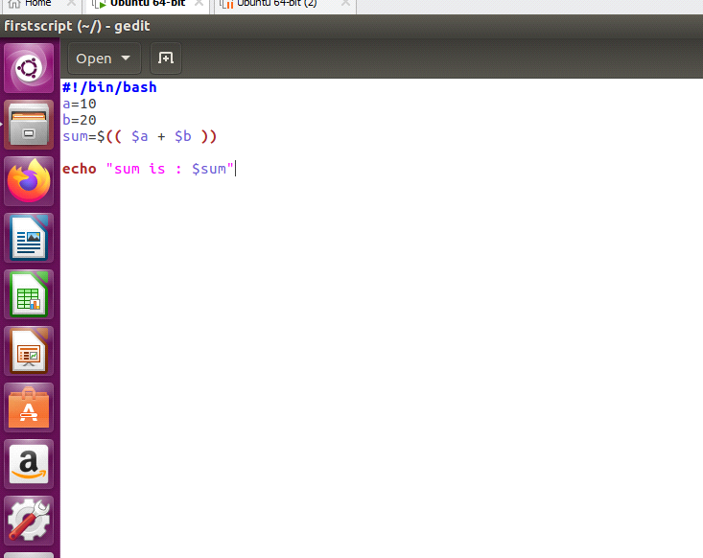

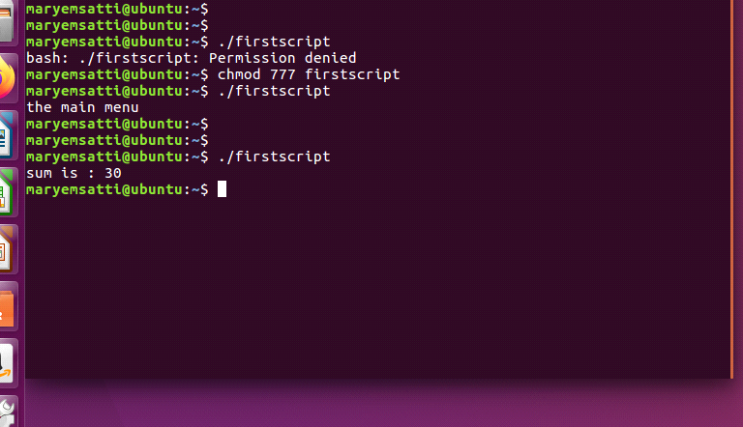

**Exercise 4:**

Write shell script that takes string from user, and make folder with named with string. Folder should contain file with named timestamp. Having current time and date written on it. **02**

**Answer**

**Code:**

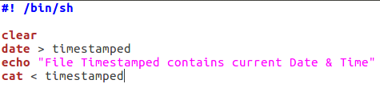

**Commands:**

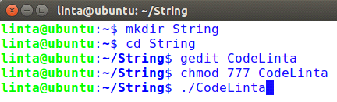

**Output:**

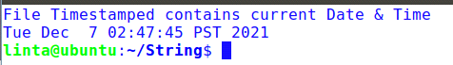

**Date Saved in file “TimeStamped”:**

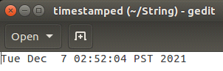

**Exercise 5:**

Write a shell script to get the total count of the word “Linux” in all the “.txt” files and also across files present in subdirectories. **02**

**Answer**

The following is the test script/command which recursively searches for the “.txt” files and returns the total occurrences of a word <Linux>.

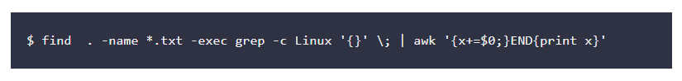

**Exercise 6:**

Write shell script that defines 2 integers and one float value like

a=5

b=7

c=5.5

Perform multiplication of integers then divide with float.

and finally print result with four decimal places. like 6.3636

you have to use pipe operator ( | ) to send variables to **bc** utility for arithmetic. **03**

**Answer**

